Interview Task
Marco Montez
16 December 2019

The tasks below consisted of an interview project for a company.
Task 1.1 was the practical development of a Classification Algorithm; Task 1.2 was the theoretical explanation of how a time-series forecasting problem would be solved.
Task 2 were SQL questions.

Task 1: Delivery problem
- Build a predictor to inform whether a payment occurs ahead of time, on time or if it's delayed. You consider that a payment is on time if it occurs during the same month of the due date.

The objective of this problem is essentially to build a classification algorithm that has three possible outputs (-1:Delayed, 0 : On Time, 1 : Up Front). Which correspond to the timeliness of the payment or transaction.
This resolution of this problem was divided into several stages:
- Data Greeting
- Data Pre-processing / EDA
- Feature Extraction
- Build Model and Cross-Validation
Which are implemented in a Jupyter Notebook, called .
1 – Data Greeting
The variables from the dataset were first analyzed to get a general feel for the data, such as the number of rows and columns of the dataset, as well as the null counts.
A correspondence between the column names and their meaning was done, by searching SAP documentation, and was stored in a separate Excel file.
2 – Data Pre-processing / EDA
Some fields, such as ‘MANDT’ were removed since they didn’t have valid or relevant information. ‘MANDT’ had only the same value repeated.
The data types were converted to more useful ones. Example converting DUE_DATE from object to datetime.
Next the dataset was trimmed in a temporal fashion, since the samples on the extremes of the timeline provided abnormal results.
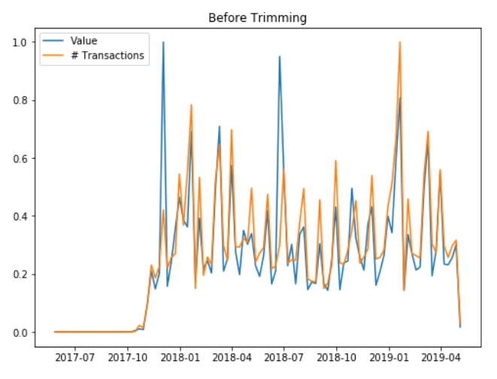

A column (‘PAY_RATING’) that encoded if the payment was made On Time, Delayed or Upfront was added. The figure below shows the distribution, across the total dataset of the pay rates.
The big majority ~ 69 % payed on time, ~19% Delayed and 12 % paid UpFront.

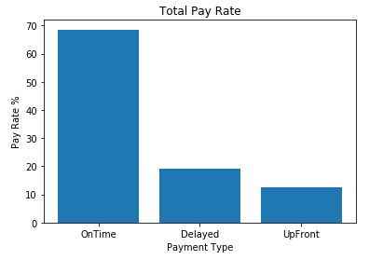
Fig X: Total pay rate distribution
Next the distribution plot for each variable was analyzed and it’s effect on the Pay Rate. The distribution of the Nan values of each variable was also analyzed to check if the nan values contained relevant information. In other words, were the nan randomly picked or did they have a determinist process that generated them?
Below is the example of an analysis to the MANSP field. Fig X has the % of samples for each label. In this case 97% of the variables were Nan.
Fig X shows the correlation between each label and the Pay Rate behavior. Label 6 and 7 have a very high chance (~95%) of being paid delayed, label A on the contrary has a high chance of being paid OnTime.
And in Fig X is the Distribution of the Nan Values. They have a very close distribution to the original distribution. Which makes sense since 97% of the values are nan.
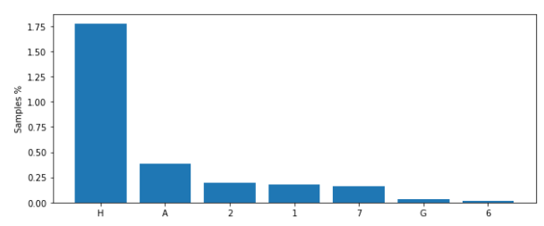
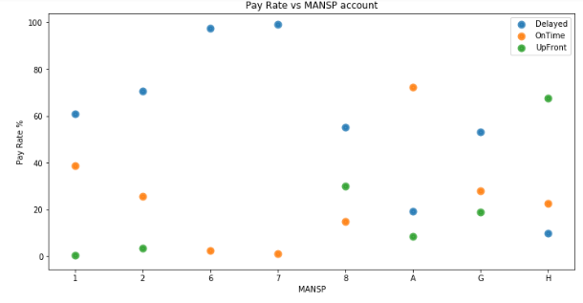
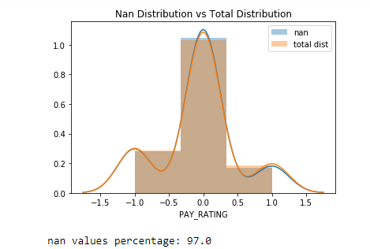

3 – Feature Extraction
When analyzing the fields it became apparent that certain labels possessed similar characteristics and could therefore be grouped and formed a composite feature.
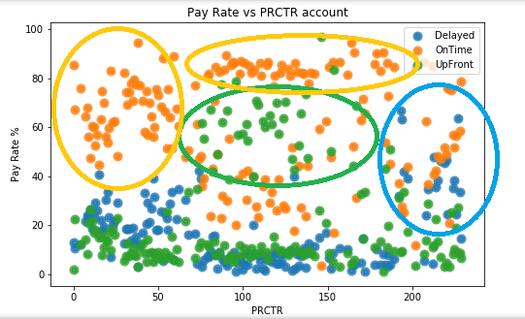

These groups were made using the k-means clustering algorithm. This resulting in aggregating several features (1000’s to 100’s) with similar information into a very limited number of features (4-6).
The cluster used for this label did 4 clusters, and they can be seen below in Figs XYZ.
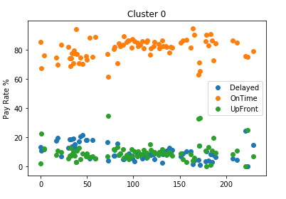
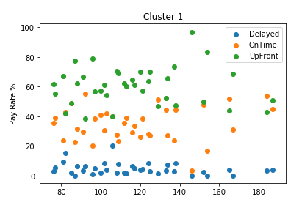
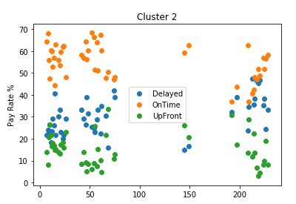
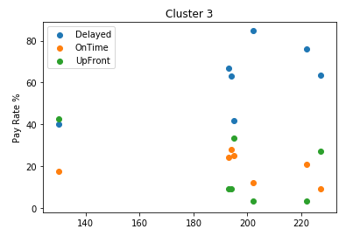

Each cluster “choose” different characteristics. C0 (Cluster 0) and C2 chose labels with high and medium On Time rate probability. C1 chose high Upfront labels and C3 picked high Delayed labels.
In this case hundreds of different labels were transformed into just 4 groups. Below in Fig X are exemplified the pay rates for each of the 4 extracted features.
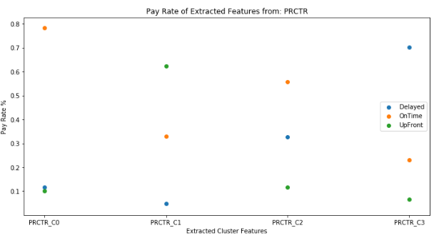
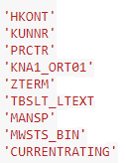
In the end 9 raw features (cols) were chosen to be part of the model. They were clustered to extract the relevant information.

4 – Model and Cross-Validation
A simple logistic regression was implemented.
Using the clusters of the previous 9 columns as features.
It achieved an average accuracy of 77,4% . Which is a 9% improvement over the initial 68.5 % “dumb prediction”.
The dumb prediction is to considered all payments to be On Time, since that is the most likely event.
The cross-validation was done in several ways: Cross K-Fold, Shuffle N Splits, Stratified K-Folds, and Stratified shuffle Splits.
The cross-validation with the least std was the shuffle split and the stratified shuffle split. These two provided very similar results.
This concludes the first “Iteration” of the problem.
The next iteration would be to try other algorithms such as SVM, GBM etc.
Create new features.
Optimize existing features, by further investigate the correlations between current features. Dispose of multicollinearities, remove the least significant features such as MWSTS_BIN_C3, which has a 3 % correlation with the payrate.
Do some hyper parameter tuning of the chosen models.
And eventually do some ensemble and combine the best models.
- Build a 6-month forecast of the monthly sum of the variable VALUE_EUR for all HKONT values.

This problem is a time-series forecasting problem.
This resolution of this problem is very similar to the above, having the same layout.
- Data Greeting
- Data Pre-processing / EDA
- Feature Extraction
- Build Model and Cross-Validation
This is a regression problem unlike the previous classification one.
After the data greeting and pre-processing / EDA. The first approach would be to apply some Seasonal Arima models to do a rough estimate of the future behavior, based on past transaction values.
After that to investigate the correlations between other variables and the transaction values.
Try and extract variables who are good predictors of the Value. For example the number of transactions is probably high correlated with the total of the transactions.
The Due date is probably also related to the value, since most people pay On Time.
And in the end use some model to do time-series forecasting. Maybe a simple model like a seasonal Arima, or a more complex one, such as neural Nets or LTSM.
These models would then be examined and cross validation to choose the best (or combination of the best ones).
When cross validating it would be important to keep the temporal order by not using future data to train and then test on past data.

Task 2: SQL
a) Write a SQL query that displays the number of customers per industry.
select COUNT(CUSTOMER_ID) from Customer GROUP BY INDUSTRY;
b) Write a SQL query that displays the average invoice total per industry.
SELECT AVG(Sales.invoice_total), Customer.industry
FROM Sales
INNER JOIN Customer ON Customer.Customer_ID=Sales.Customer_ID
GROUP by Customer.industry;
c) Write a SQL query that displays what each customer spent per month, if that value is bigger than 100.
SELECT Customer_ID, SUM(invoice_total), sale_date
FROM Sales
GROUP BY customer_id,sale_date
having SUM(invoice_total)>100;
d) Write a SQL query that that ranks clients within Industry based on respective sales total.
SELECT Sales.customer_id, SUM(Sales.invoice_total), Customer.industry, rank()
OVER ( partition by Customer.industry order by SUM(Sales.invoice_total) )
FROM Sales
INNER JOIN Customer ON Customer.Customer_ID=Sales.Customer_ID
GROUP by Sales.customer_id;

